Report on Special Assistance at Belfast International Airport

July 2023
Contents

1. EXECUTIVE SUMMARY 2
2. INTRODUCTION 3
3. METHODOLOGY 4
4. FINDINGS 4
5. CONCLUSIONS 14
6. NEXT STEPS 14

1. EXECUTIVE SUMMARY

1.1 European Regulation (EC) 1107/2006 (the Regulation) provides rights for passengers with disabilities and reduced mobility when travelling by air. This has been retained in United Kingdom (UK) law following the UK’s exit from the European Union (EU).

1.2 The Regulation requires all airports and airlines in the UK and EU to provide assistance to passengers with a disability or reduced mobility. The Consumer Council has been designated by the Civil Aviation Authority (CAA) to be the complaints handling body for the Regulation.

1.3 In 2014 the CAA issued guidance requiring airports to consult with passengers with a disability or reduced mobility. This report details the findings of a meeting on 14 June 2023 of the Belfast International Airport’s Accessibility Forum which involved a tour of the airport building. The Forum is made up of a range of organisations which represent consumers with a disability or reduced mobility.

1.4 The Forum was positive about the airport’s facilities and special assistance services that are provided to passengers. In particular, the Forum was appreciative of the efforts the airport had made to implement the suggestions made during the previous year’s visit, many of which had already been put in place. There were a number of further suggestions made by participants. These focussed on:
- Updates to website to improve awareness of airport special assistance services;
- Further improvements to signage;
- Special assistance seating;
- Providing a handrail on the ramp to the arrivals hall/exit;
- Toilet facilities.

1.5 The findings of the visit will be shared with the airport. An update on progress made against the recommendations will be reported by the airport to the Accessibility Forum at its next meeting.

2. INTRODUCTION

2.1 In 2006 European Regulations came into place that require all airports and airlines in the EU to assist passengers with a disability or with a reduced mobility (PRM) when travelling. These have been retained and written into UK law since its exit from the EU. Airlines licensed in the EU, operating flights from a non-EU country into the EU must also assist passengers.

2.2 The Consumer Council has been designated by the CAA as the complaints handling body for the Regulation relating to an airport in Northern Ireland or a flight departing from a Northern Ireland airport. The Consumer Council works alongside the Northern Ireland airports to ensure that their services continue to meet passengers’ needs.

2.3 In 2014 the CAA issued guidance requiring airports to consult with passengers with a disability or reduced mobility. This ‘should, as much as possible, include practical inspections of airport services (generally using ‘walk throughs’). Airports should also consider convening regular forums containing representatives of disability groups and individuals’.

2.4 In 2019, the Consumer Council worked with Belfast International Airport to establish an Accessibility Forum at the airport. Membership of the Accessibility Forum consists of a range of organisations that represent consumers with a disability or reduced mobility. The aim is to provide a forum for users of the airport’s Special Assistance services or their representatives to share their knowledge and experiences of services at the airport.

2.5 The intended outcome of this visit is for the Forum to continue to work with the airport in looking specifically at special assistance to gain a better understanding of issues faced by passengers using this service. In particular, it is intended to identify areas where it works well, and to implement suggestions made by forum members to help make travel more convenient for those passengers. The airport will provide feedback on actions taken from the recommendations made at the next forum meeting.

2.6 Belfast International Airport and the Consumer Council would like to thank those participants who took part on the day.

3. METHODOLOGY

3.1 The Forum met at the airport on 14 June 2023. There were seven participants from a range of organisations that represent consumers with a disability or reduced mobility.

3.2 The Forum began with a presentation by a member of the airport’s car park staff about the process for passengers wishing to park at the airport. A presentation was also given on improvements made as a result of the Forum’s recommendations from their visit the previous year, and refurbishment plans for the airport which would be complete in 2024. The Consumer Council and airport staff then guided the group through the airport, beginning at the check-in area and finishing in the arrivals areas. A brief round-up discussion with the whole Forum was held at the end of the tour.

3.3 Staff from the Consumer Council took notes at the visit and recorded the suggestions that were made by the group.

4. FINDINGS

4.1 The following section provides a summary of the key discussion points that were recorded with corresponding recommendations. The findings are set out in the order of the various stages of moving through the airport, with an overall summary provided at Annex 1.

Arrival at the airport/parking area

4.2 The group noted the introduction of thirty minutes free parking for blue badge holders in the short stay car park. This also applied to drivers who were dropping off or picking up a blue badge holder.
4.3 Discussion took place around car parking for passengers requiring special assistance and the frustrations arising from those who did not require assistance using the bays reserved for blue badge holders. Airport staff did regularly carry out “spot checks” but there were many grey areas – for example passengers parking legitimately but who had forgotten to display their blue badge. There was a need to address parking enforcement and the airport would continue to work with stakeholders to address the situation.

4.4 There was a bus available on request from the long-stay car park but participants were not aware of this option.

Recommendations:

- Make clear on the website that it is advisable for passengers requiring special assistance to pre-book parking spaces.
- Publicise the five-stage process for booking car parking that allows passengers requiring special assistance to avail of car parking in the short stay car park at the cheapest car parking rate – for example a short video. This should emphasise the importance of displaying a copy of the blue badge if passengers need to travel with the original.
- Currently pre-booking must take place by telephone. Prioritise developing an online option.
- Publicise the availability of accessible bus transport from the long-stay car park. It is helpful to know that this option is available particularly at very busy times.
- Additional signage in the long stay car park should make clear that passengers should make their way to the bus shelter to call for the bus service.
- Consider implementing a covered walkway from the long stay car park to the main terminal building.
- Work with other stakeholders to explore potential penalties for misuse of blue badge parking and publicise these.

4.5 Airport staff drew the group’s attention to a new “chat bot” feature on the website which enabled passengers to find specific information online. It had proven very popular since its launch in August 2022 and was a particularly welcome function for people who find it difficult to use a telephone. Participants noted that it did not currently have capacity for voice recognition which could cause issues for people who were blind or partially sighted.

Recommendation:

- Consider how the “chat bot” could be further developed to cover voice recognition so that all passengers have the opportunity to use.

4.6 Work was ongoing to the airport entrance to make directions as straightforward as possible for passengers. There is different coloured paving at the “drop off” zone along with a more straightforward route into the terminal building and better signage for Arrivals and Departures. Best practice for assistance dog spending areas was discussed.
Recommendation:

- Guidance on assistance dog spending areas to be forwarded to airport.

Terminal Building

4.7 Participants were very pleased to see that a number of changes had been made as a result of the recommendations made at the last visit. These included:
- Large “statement” signage in key areas of the terminal building (Figure 1).
- Better signage placement, including at lower level in some areas (Figure 2).
- Advertising signage was also being removed/re-positioned across the airport to avoid “clutter” (Figure 3).
- The roll out of larger Flight Information Display screens across key areas of the terminal (Figure 4).
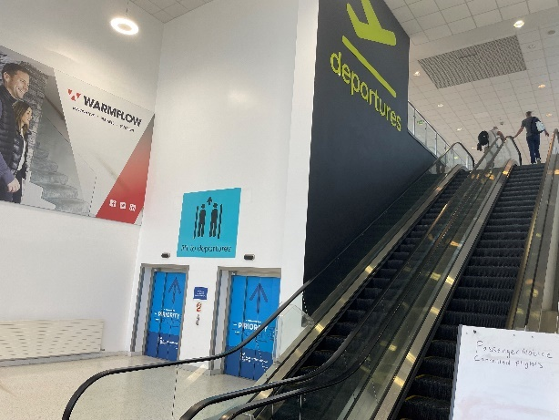
Figure 1: Example of new “statement” signage
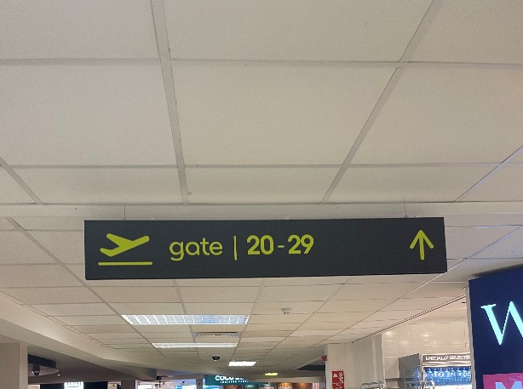
Figure 2: Example of clearer signage placement
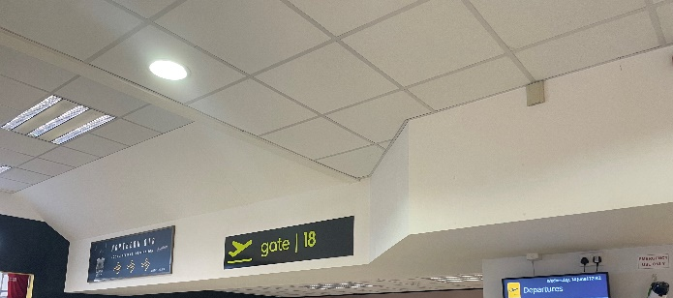
Figure 3: Example of advertising signage to be removed
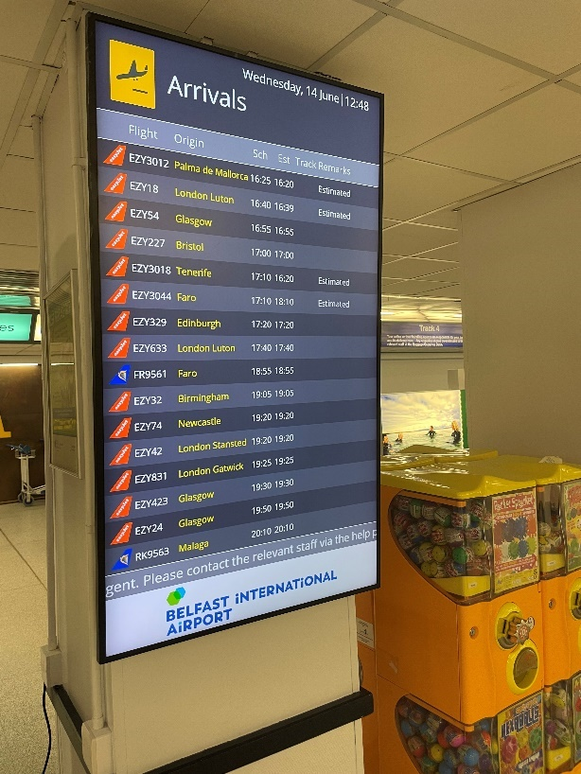
Figure 4: Larger flight information screen
The group also noted new signage which was consistent across the airport, whereas previously there had been three different styles. As expressed at the previous visit, the colour scheme (light blue on black) is not ideal for blind or partially sighted people, or people with dementia. The group appreciated that this was a corporate decision by the airport owners, and not one that the airport could change. It was also noted that there was no guidance from the Civil Aviation Authority (CAA) on best practice for accessible signage.
4.8 The group commented on the slope of the ramp to Arrivals/Exit which several thought was very steep particularly for those with mobility issues.
Recommendation:
- Consider installing handrails and seating along the ramp to arrivals/exit.
Check-in area

4.9 Participants noted that the Special Assistance desk was clearly signposted at the entrance to the check-in area and was due to be extended as part of the future refurbishment plans (Figure 5). New wheelchairs were now being used with better brakes. The group queried whether signage at the check-in desks could be made more prominent and announcements made when check-in is open.

Recommendation:

- More prominent signage and announcements at check-in.

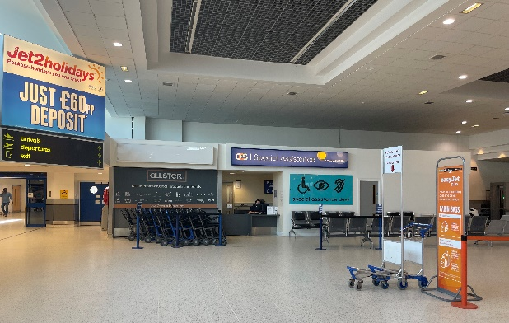
Figure 5: Special Assistance area at check-in

4.10 The group discussed issues with abuse of the sunflower lanyard system, including difficulties enforcing the “1 plus 1” policy (allowing only essential family or an assistant to accompany the lanyard holder through security) as on occasions large groups were insisting on using the lane reserved for special assistance. Airport staff asked for assistance in raising awareness of the importance of adhering to this policy to ensure a pleasant experience for all passengers.

Recommendation:

- Consider ways to raise awareness of the airport’s “1 plus 1” policy.

4.11 Airport staff also raised the benefits of “pre-notifying” the requirement for special assistance to enable staff to plan accordingly, taking into account the need for flexibility as set out in the regulation. Staff raised issues with pre-notifications not coming through for passengers who had booked via the easyJet app or easyJet Holidays. There were also issues with requests for special assistance involving hidden disabilities for passengers booking with Jet 2.

Recommendation:

- Consumer Council to follow up on pre-notification issues with respective airlines and consider ways to help raise consumer awareness of the benefits of pre-notifying requirements.

4.12 The group praised the bright yellow roping which clearly distinguished the priority security lane (Figure 6). Previously this had been a mixture of colours and it was unclear where passengers should queue.

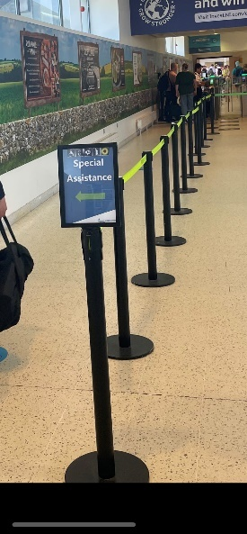
Figure 6: Special assistance lane towards security area

4.13 The attitude of security staff was raised as a general issue and the importance of customer service training to ensure the journey through security could be as smooth and stress free as possible for both passengers and staff.

Recommendation:

- Look at ways of enhancing customer service training for airport staff. Participant organisations in the visit are happy to work with the airport on additional training and access to online resources.

4.14 The possibility of an alternative route to the departures lounge i.e. without needing to pass through the duty free/shopping area was raised. This would be particularly important for people with autism or dementia who would welcome a calmer, less noisy passage.

Recommendation:

- Consider an alternative “quiet” route to the departures lounge after security.

4.15 Participants noted the availability of a “quiet area” for passengers to sit away from the busy general departures area. Signage for this was small and difficult to read (Figure 7).

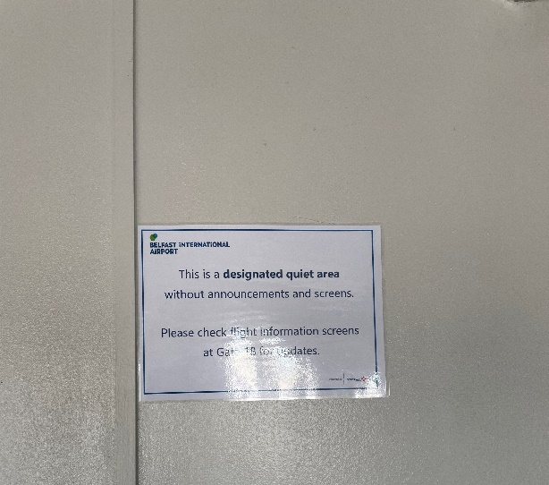
Figure 7: Current quiet area signage

Recommendation:

- Update and enlarge signage for quiet area in departures area.

4.16 The group noted that the flooring throughout the terminal building was being replaced and the seating refurbished with foam covering on all special assistance seating (Figure 8).

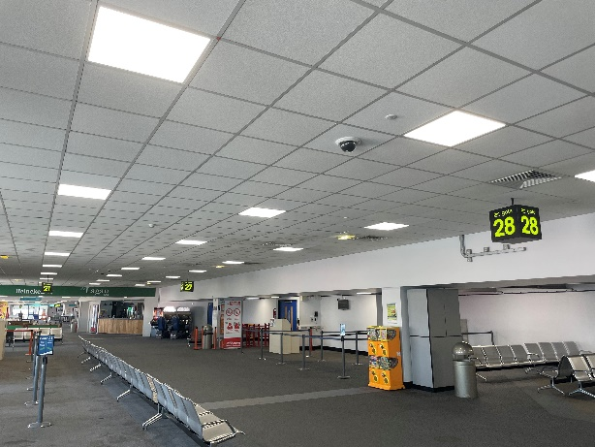
Figure 8: Example of flooring/seating to be replaced during refurbishment

4.17 A number of suggestions were made regarding toilet facilities for passengers requiring special assistance. In particular, a participant raised the issue of toilet accessibility for stoma users. Some toilets had vertical sanitary waste bins which may not be appropriate to dispose of stoma bags (Figure 9).

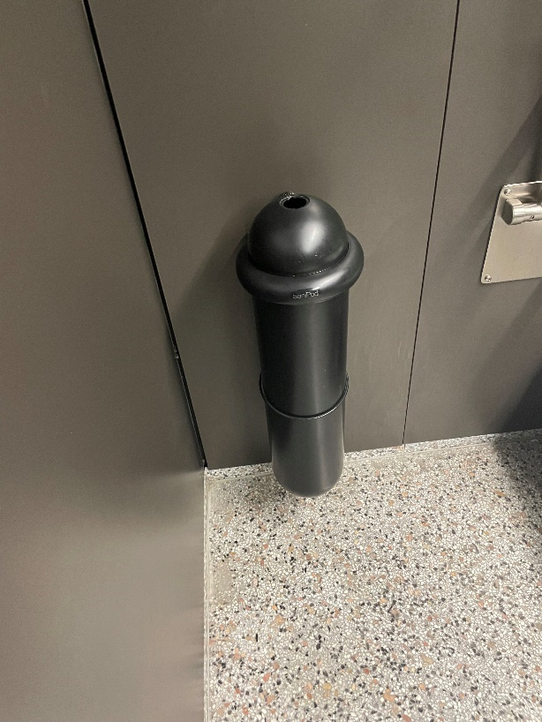
Figure 9: Sanitary waste disposal bin in accessible toilet

Recommendations:

- Cubicles should have suitable waste disposal facilities for stoma bags.
- Consider putting a form of automatic door in place for special assistance toilets so that passengers who may be travelling alone can more easily access.
- Ensure hand dryers in all accessible toilets are suitably placed.
- Consider converting the shower facility within the baggage reclaim hall into an additional Changing Places toilet.

4.18 The group noted that signs to the “Baggage Reclaim” should make clear that this is also the Exit (Figure 10). The lift to baggage reclaim should also have additional signage leading to it as its direction is currently unclear (Figure 11). The area towards the lift could also be made more welcoming to passengers. The baggage reclaim hall itself would benefit from special assistance seating (Figure 12).

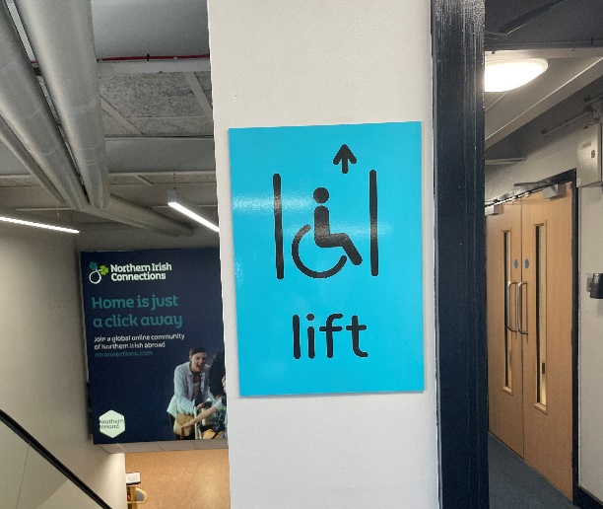
Figure 10: Baggage reclaim signage Figure 11: Signage for lift to baggage reclaim
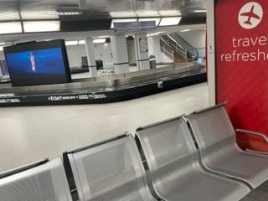
Figure 12: Seating in baggage reclaim area

Recommendations:

- Additional signage alongside Baggage Reclaim signs clearly stating that this is also the way to Exit the terminal.
- Additional signage in the area towards the lift to baggage reclaim making clear that it is around the corner, not directly ahead.
- Install special assistance seating in the baggage reclaim hall.

4.19 Following a recommendation made last year, staff had spoken to third party operators in the airport to ensure that their services were as accessible as possible. The group were pleased to note that as a result, guidance has been developed to ensure lower, accessible desks are available by all car hire operators in the airport.

5. CONCLUSIONS

5.1 Participants welcomed the opportunity to tour the airport and expressed satisfaction throughout at the processes and changes that had been implemented already to improve the experience for passengers requiring special assistance. Participants were able to ask questions throughout the visit and make suggestions based on their experiences and knowledge of some of the barriers passengers may face. A number of suggestions were made, including further improvements to the website and signage, special assistance seating, provision of a handrail on the ramp to the arrivals hall/exit, and toilet facilities.

5.2 As previously noted, the airport is currently being redesigned/renovated. The group agreed to liaise with staff throughout the process which was expected to be complete in the summer of 2024. Airport staff welcome views and comments.

6. NEXT STEPS

6.1 The comments made by participants will be presented to the airport through this report. The Consumer Council will work with the airport as it implements the changes to ensure that services continue to meet passengers’ needs. An update on the progress made against the suggestions will be shared with the airport’s Accessibility Forum at its next meeting.
Annex 1 Summary of Recommendations
 | Parking
1 | Make clear on the website that it is advisable for passengers requiring special assistance to pre-book parking spaces.
2 | Publicise the five-stage process for booking car parking that allows passengers requiring special assistance to avail of car parking in the short stay car park at the cheapest car parking rate – for example a short video. This should emphasise the importance of displaying a copy of the blue badge if passengers need to travel with the original.
3 | Currently pre-booking must take place by telephone. Prioritise developing an online option.
4 | Publicise the availability of accessible bus transport from the long-stay car park. It is helpful to know that this option is available particularly at very busy times.
5 | Additional signage in the long stay car park should make clear that passengers should make their way to the bus shelter to call for the bus service.
6 | Consider implementing a covered walkway from the long stay car park to the main terminal building.
7 | Work with other stakeholders to explore potential penalties for misuse of blue badge parking and publicise these.
 | Website
8 | Consider how the “chat bot” could be further developed to cover voice recognition so that all passengers have the opportunity to use.
 | Assistance dog toileting areas
9 | Guidance on assistance dog spending areas to be forwarded to airport (note this was subsequently done).
 | Ramp to exit/arrivals
10 | Consider installing handrails and seating along the ramp to arrivals/exit.
 | Signage
11 | More prominent signage and announcements at check-in.
12 | Update and enlarge signage for quiet area in departures area.
13 | Additional signage alongside Baggage Reclaim signs clearly stating that this is also the way to Exit the terminal.
14 | Additional signage in the area towards the lift to baggage reclaim making clear that it is around the corner, not directly ahead.
 | Toilets
15 | Cubicles should have suitable waste disposal facilities for stoma bags.
16 | Consider putting a form of automatic door in place for special assistance toilets so that passengers who may be travelling alone can more easily access.
17 | Ensure hand dryers in all accessible toilets are suitably placed.
18 | Consider converting the shower facility within the baggage reclaim hall into an additional Changing Places toilet.
 | Quiet route
19 | Consider an alternative “quiet” route to the departures lounge after security.
 | Training
20 | Look at ways of enhancing customer service training for airport staff. Participant organisations in the visit are happy to work with the airport on additional training and access to online resources.
 | Seating
21 | Install special assistance seating in the baggage reclaim hall.
 | Sunflower Lanyards
22 | Consider ways to raise awareness of the airport’s “1 plus 1” policy.
 | Pre-notification
23 | Consumer Council to follow up on pre-notification issues with respective airlines and consider ways to help raise consumer awareness of the benefits of pre-notifying requirements.

European Regulation (EC) 1107/2006
People of Restricted Mobility (PRM)
Regulation (EC) No 1107/2006 (as amended by The Air Passenger Rights and Air Travel Organisers’ Licencing (Amendment) (EU Exit) Regulations 2019)
Civil Aviation (Access to Air Travel for Disabled Persons and Persons with Reduced Mobility) Regulations 2007 (SI 2007/1895)
IMTAC, Autism NI, Royal National Institute of Blind People (RNIB), Cedar Foundation, Disability Action, Age Friendly Network NI

